Day 1

Activity 4 Identify Characters on in authentic materials
Students are provided with several invitations and cards where the target characters 人，认识, and 请 are included. They must circle these characters and use inference to answer questions about the materials.

Step 1: Please circle the characters you know (students should recognize 人，请，认识)

Step 2: Can you take a guess what the occasion is?

(The card was downloaded from the website below:
http://www.google.com/imgres?q=邀请卡&start=422&um=1&hl=en&client=safari&sa=N&rls=en&biw=1024&bih=608&tbm=isch&tbnid=7ltf_Ho7fzO1rM:&imgrefurl=http://www.nipic.com/show/4/142/4208572kb8c8401f.html&docid=AfsZDOJdoN9bdM&imgurl=http://pic12.nipic.com/20110125/1234211_104323313328_2.jpg&w=1024&h=724&ei=FR9iUNOENeahiQLRhoG4Bg&zoom=1&iact=hc&vpx=299&vpy=220&dur=1990&hovh=189&hovw=267&tx=174&ty=214&sig=107052363101544997221&page=21&tbnh=111&tbnw=157&ndsp=22&ved=1t:429,r:12,s:422,i:177)

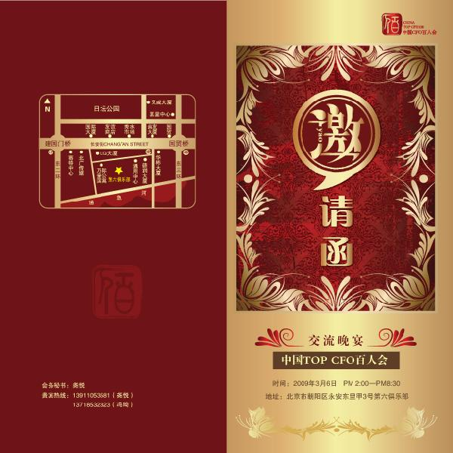

(The card was downloaded from the website below:
http://www.google.com/imgres?q=邀请卡片&start=434&num=10&hl=en&client=safari&rls=en&biw=1024&bih=608&tbm=isch&tbnid=Wr_qUxVwPQeZmM:&imgrefurl=http://www.sharejs.com/vector/chaoliu/5244&docid=eBo3xqsHx6oicM&imgurl=http://www.sharejs.com/vectors/d1/11274/sharejs_com_1001.eps.jpg&w=600&h=600&ei=-3RnUPX5CsXUiwK9yYHgDw&zoom=1&iact=hc&vpx=674&vpy=13&dur=6971&hovh=225&hovw=225&tx=184&ty=208&sig=107052363101544997221&page=21&tbnh=140&tbnw=140&ndsp=24&ved=1t:429,r:16,s:434,i:201

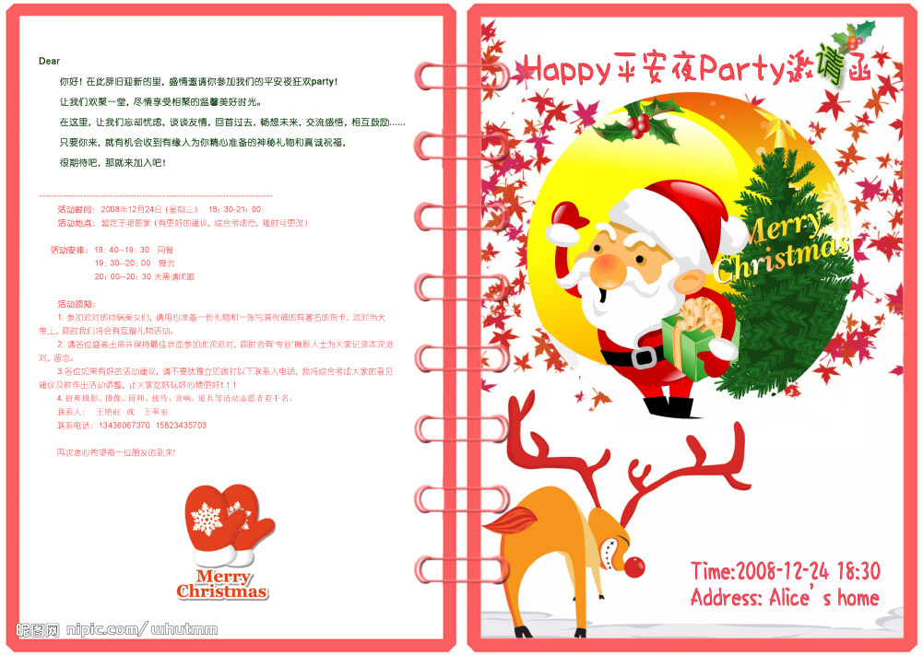

(The card was downloaded from the website below:
http://pic1a.nipic.com/2009-01-08/20091822358429_2.jpg)

Please circle the characters you know. Students should recognize 人，请，认识.

shēngrì kuàilè
张大伟的生日派对

日期：1月5号
时间：晚上6点
地点：中华路100号
人数：10－20人
请你们带另一半来参加大伟的生日派对！
认识的不认识的朋友我们都欢迎！

